Starting Equipment: 500 + 2d10, 2 uncommon, 1 rare

Characters:

* Elf Fighter
* Human Rogue
* Half-Orc Cleric

The players have been called to investigate suspicious activity around the tomb of the damned souls. Undead have been spotted nearby, as well as numerous goblins have made camp outside of it. Our 3 heroes after defeating a nearby goblin encampment discovered the tomb and have entered inside. Legend has it that thunderous roars can be heard from deep within, and the are has a permanent sulfuric odour to it. This is nearby the town of “Kings Watch”

Starting Room: 20ft radius circle, 10ft pool of water in the centre, hallways N,W,S, 4 torches in “corners”. Domed roof

1. 40ft x 20ft rectangle, pile of boxes, pile of crate, 1 zombie in each. Door on far south wall. DC-15 to pick. No torches Ghost will appear if they linger for t0o long. Skeleton from 3 appears if they make too much noise.
2. South corridor has wall at the end. AC-17 HP-30. Can hear a faint chattering sound. Give surprise round if they break through
3. 40ft x 40ft octagon. DC-20 perception check to notice glyph on ceiling of entrance. DC-15 arcana to discern. Glyph alerts two flaming skulls in the south hallway and skeleton who comes through the east door and slams it shut. DC-10 investigation skeleton reveals key. DC-20 to pick
4. 10ft spike trap covered in vines. DC-10 Acrobatics or Athletics to catch ledge, DC-15 to make. Lighter characters can make an easier acrobatics check to clear. Corridor turns south, and declines 30ft lower. If character falls in the trap they take 2d10 piercing + 4d10 poison w/ half on DC-13 Con save
5. T-intersection at bottom of stairs. East leads to a DC-15 perception hidden door. DC-15 flame trap. Treasure chest containing 3 gems (500gp) each and 1 Greater Healing Potion
6. West corridor turns south and opens into the short side of a 40ft x 60ft trapezoid. In the SW corner is 2 goblins, a goblin boss, a hobgoblin captian, 2 bugbears, and a chief camping by a fire. Narrow corridor going out of SE corner behind some boxes DC-15 to notice.
7. Corridor turns south and opens up into a larger cavern. Players are on a 15ft x 10ft ledge, PCs with darkvision can see movement 50ft down, DC-20 to see what is down there. There is a rickety bridge that players can attempt to use to cross. Roll a d100, and if <= 20, the bridge collapses. DC-20 acrobatics to dive for the closest ledge. The ledge on the far side is the same size, 60ft away, 20ft down with a corridor behind it.
8. Corridor goes S, then E, then N, then W and opens up into the bottom of the cavern. An Ogre, Ogre Zombie and an Umber hulk are all sleeping DC-15 to sneak by. Chest is by them with an uncommon. Roll on Treasure hoard 5-10. As the players descend remark how the temperature of the ravine seems to be rising, and the
9. Corridor heads west, there’s a DC-10 to see tripline trap that sets off a see of swinging axe traps. DC-15 to disarm.
10. Next room is 50ft x 50ft with an unlit brazier in the middle, no torches and a book on a pedestal facing the portcullis on the west side of the room. The book can’t be read in the dark, and seemingly becomes more clear as there is more light near it. If the brazier is lit, a DC-15 dex save is made for all within a 20ft radius, with a fireball being summoned dealing 8d6 fire. On the entrance way high above, there is a carving of a toad on the south side and a skull on the north. Near the portcullis is 3 4 sided cubes with a toad, dragon breathing fire, skull and sword over a shield on each. If the players activate the fireball trap, the dragon breathing fire in the middle near the entrance collapses. If the characters put the wrong combination in after pulling the lever in the middle, a bolt of lightning hits the pc who activated it, with the same saves and damage as the fireball.
11. The corridor leads into a 25ft radius hemispherical room. The room is lit up with what appears to be the night sky projected on the sealing. On a platform in the middle is a elderly human mage, in black and red robes, a black twisted staff with a dragon head and a long grey (burnt) beard. His name is Agevras the Desecrator, and beside him is a wight. After a monologue he sends the wight after the PCs. Either can spend a bonus action raising a zombie in the room who has as AC-10, HP-1, +3 to hit and deals 1d6+1 bludgeoning. This happens on a 5-6 after rolling a d6 at the beginning of their turn. He casts mage armor while doing his monologue

Agevras the Desecrator:

Mage template

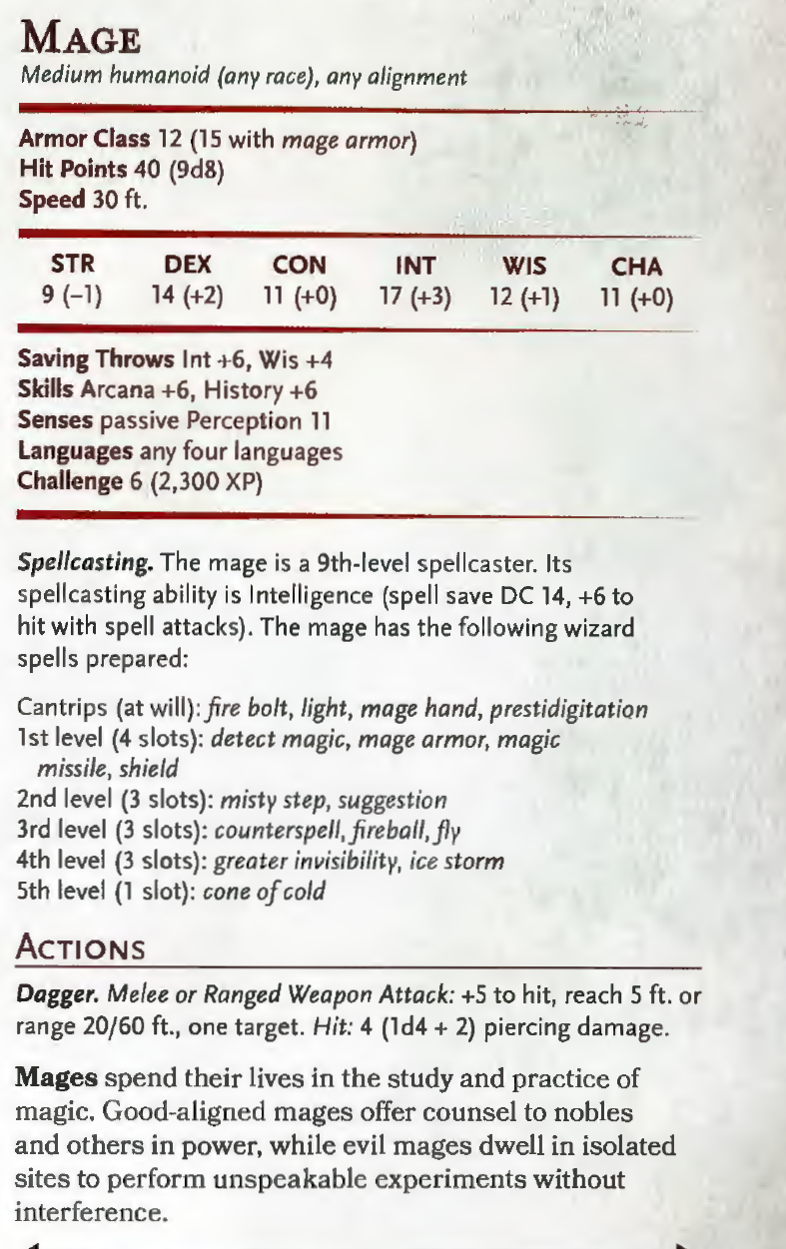



Replace fire bolt with chill touch, magic missiles with ray of sickness, suggestion with ray of enfeeblement, fly with vampiric touch, ice storm with blight.

1. The corridor leading out has a glyph of warding that is a DC-10 to see, DC-15 to identify, and if activated alerts the young red dragon in the final chamber.

